Key points for students
The key points to remember for this project are summarised below.
Outputting messages and inputting variables
The basic print command: print('Hello World')
Printing variables: print(name)
Combining strings and variables: print('Hello', name)
Assigning a value to a variable: name = 'John'
Asking the user to input data using a prompt and assigning the data input to a variable: name = input('What is your name? ')
Specifying that a whole number will be input: stock = int(input('How many items in stock? ') )
When using a variable to keep track of a value, such as a score, the variable needs to be initialised to zero before the main body of the program, for example: score = 0
Random module
The random module is imported using import random at the top of the program.
Random numbers are generated using random.randint. For example, to generate a random number between 1 and 10: number = random.randint(1, 10)
The structure of a for loop
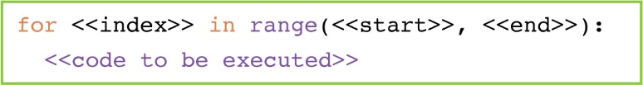
For example, to output the number 1 to 10:
for i in range(1, 11):
print(i)

if, elif and else statements
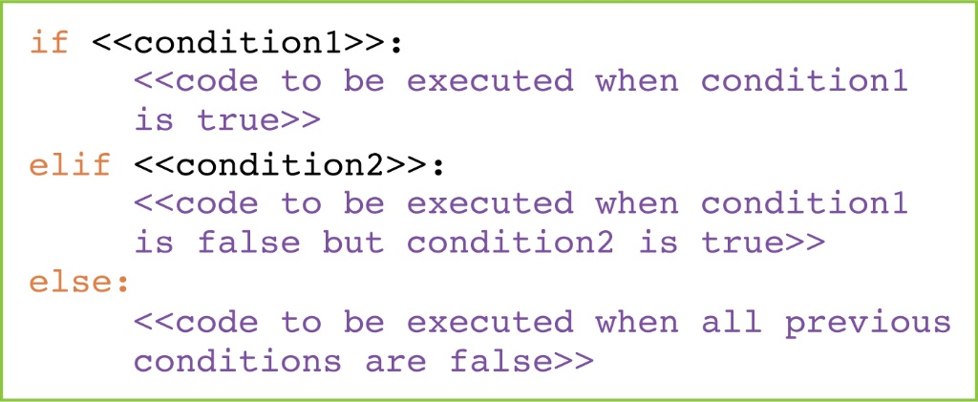
Every condition must be a question that can be answered with true (yes) or false (no).
Use if for the first condition to be checked. Use elif for each additional condition to be checked. The else code runs if none of the preceding conditions have been met.
Indent the block of code to be run when a condition is met. Stop indenting the code to return to the main program.
Boolean operators
Conditions are written using Boolean operators:
Operator | Meaning
> | greater than
>= | greater than or equal to
< | less than
<= | less than or equal to
== | equal to
!= | not equal to
For example: if age >= 18 will check whether the value stored in the variable age is greater than or equal to 18.

String handling
To find the length of a string: len(myString)
To look at each letter in a string we can use a for loop to return each letter in the word:
word = ‘computer’
for i in range(0, len(word)):
letter = word[i]
We can then process each letter in turn.
However, there is a much simpler and tidier method, which will return each letter in the word in turn:
For example, the code above written using this method would be:
word = ‘computer’
for letter in word:
Boolean variables and the logical operator and
A Boolean variable is a variable that is only True or False.
And is a logical operator that allows for two conditions to be checked; for it to return True, both conditions must be true.
You can use Boolean variables in an if statement containing two conditions to be checked using and as follows:
one = True
two = True
if one and two: # 1
print(‘Both conditions are true.’)
# 1 we could say if one == True and two == True but we don’t need to

